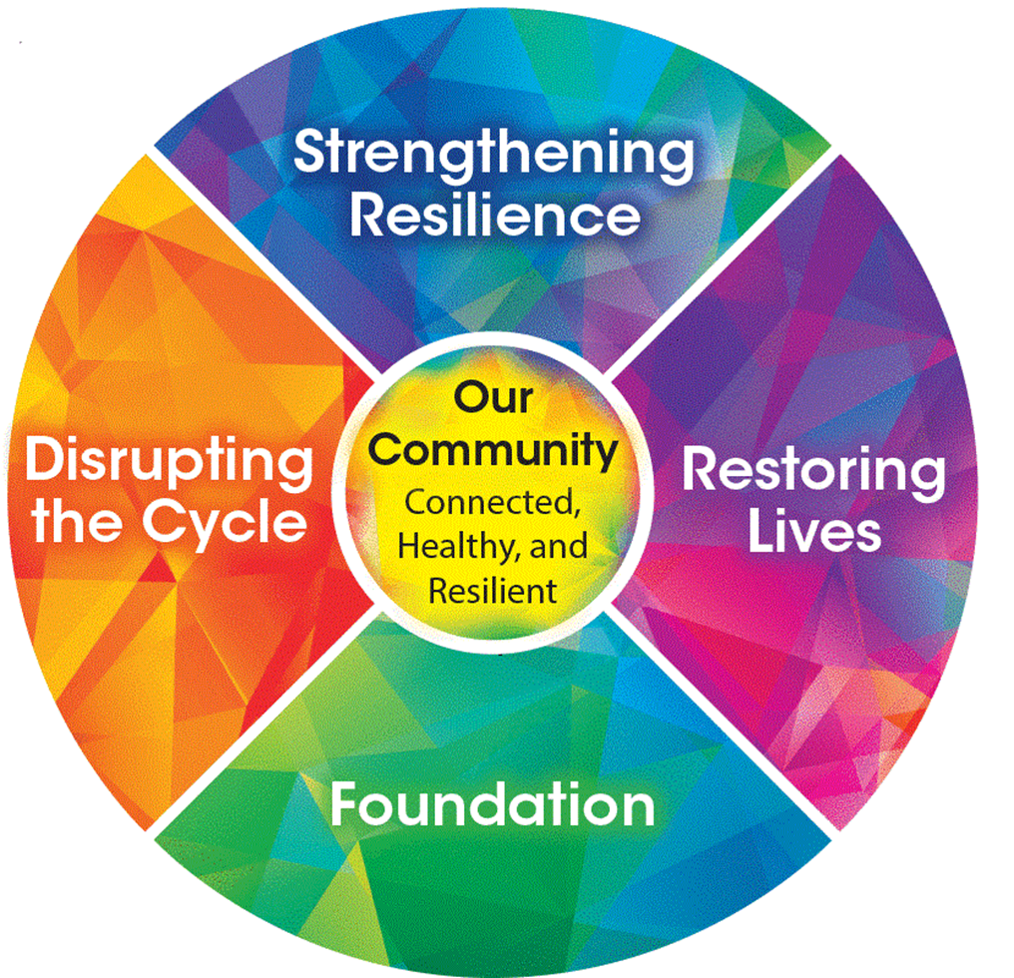
Moving from Principles to Practice
Action Plan
This Action Plan is for your personal use. You are encouraged to complete it with the ideas you learn in this workshop and then take it back to your organization for discussion.

Based on your self-assessment, what are 3 areas where this works excels for you or your team?

- ___________________________________________________________________________

- ___________________________________________________________________________

- ___________________________________________________________________________

Identify 3 opportunities that you can take back to your organization/team for discussion?

- ___________________________________________________________________________

- ___________________________________________________________________________

- ___________________________________________________________________________

What are 1 – 3 challenges/barriers you anticipate facing when integrating the principles of trauma-informed practice? What can you do to address those?

Challenge | Addressing Challenge

Goal: ______________________________________________________________________________

___________________________________________________________________________________

Steps to Achieve Goal

 | Task | Responsible | Timeframe
1
2
3
4
5
6
7
8
9
10

Comments/Notes:

