Leaders’ Guide

Adverse childhood experiences (Aces) & Trauma-informed care (TIC)

A [Organization name] Strategic Initiative in Partnership with Community

Resilient and Trauma-Informed Community Team Talking Points

What we are trying to do

[Organization name] has a responsibility to understand and address the impact of ACEs within the context of [Why is it important to your organization?]. We are working to create an environment that is trauma-informed and that builds the resilience of both [population served] and staff. We are accomplishing this by building a foundation of common language and understanding around ACEs, trauma, and resilience, and using that knowledge to create conditions for [population served] and staff to thrive regardless of their challenges.

Why It is important

Adverse Childhood Experiences (ACEs) and Trauma Informed Care is a strategic priority for [Organization Name]. As an [Sector represented; i.e. education, government], we play an important role in Creating a Resilient and Trauma-Informed Community. Supporting trauma-informed environments can have significant impacts on [name benefits relevant to your organization]. ACE’s are common across all populations. By understanding what that means, we can use that knowledge to connect with others by using a different lens of care and support for all.

What success Will look like

Integrating our knowledge of ACE science will enable us to develop practices and interventions that acknowledge the high prevalence of ACEs and are grounded in the understanding and awareness of the impacts of trauma. We will see success when staff and [population served] feel supported in [goals of population staff being served] and are able to build the resilience needed to thrive in the face of challenges.

What we need from you

[Below are some examples. List what your ask is for your organizational leaders]
- Connect inquiries, proposed activities or functions related to trauma and resilience back to the [name of organization] Resilient and Trauma-Informed Community (RTIC) Team.
- Use upcoming staff meetings, board presentations, and informal meetings to share talking points. Consider inclusion of optional video/talking points.
- Encourage and support employee participation in ACE and TIC education, and strengthen your own understanding of ACE/TIC research.
- Be an advocate for trauma-informed care through your language, opportunities within the college, and future ACE/TIC work.

Additional Video with Talking POints

JUST THE BEGINNING – Establishing the Foundation to Support the Work Ahead

Resilient and Trauma-Informed Community (RTIC) is a framework adopted by community partners. The Foundation of our collaborative effort is built upon what we have learned about adverse childhood experiences (ACEs).

RTIC Overview Video (15 min)

WHAT WE KNOW – Adverse Childhood Experiences (ACEs) and Trauma-Informed Care (TIC)
ACEs influence health and well-being: More ACEs lead to an increased risk for poor mental and physical health outcomes.

Trauma-Informed Care: A perspective shift that promotes recovery and acknowledges the role of trauma in someone’s life.

Resilience can help: Resilience is the ability to bounce back. With appropriate supports and help, people can heal and thrive despite past experiences.

Healing takes a village: Together, we are working to disrupt the cycle, strengthen resilience and restore lives. A whole community effort is needed to build a place that is connected, healthy and resilient.

WHAT WILL COME AFTER BUILDING OUR FOUNDATION

Action within Three Commitments from Prevention to Treatment to Foster Change:

- Disrupting the Cycle of Trauma: Reduce risk of child exposure to trauma through prevention and early intervention
- Strengthening Resilience: Enhance protective factors to help people bounce back and reduce risk for poor health outcomes
- Restoring Lives: Integrate accessible and effective suppports that foster healing and recovery

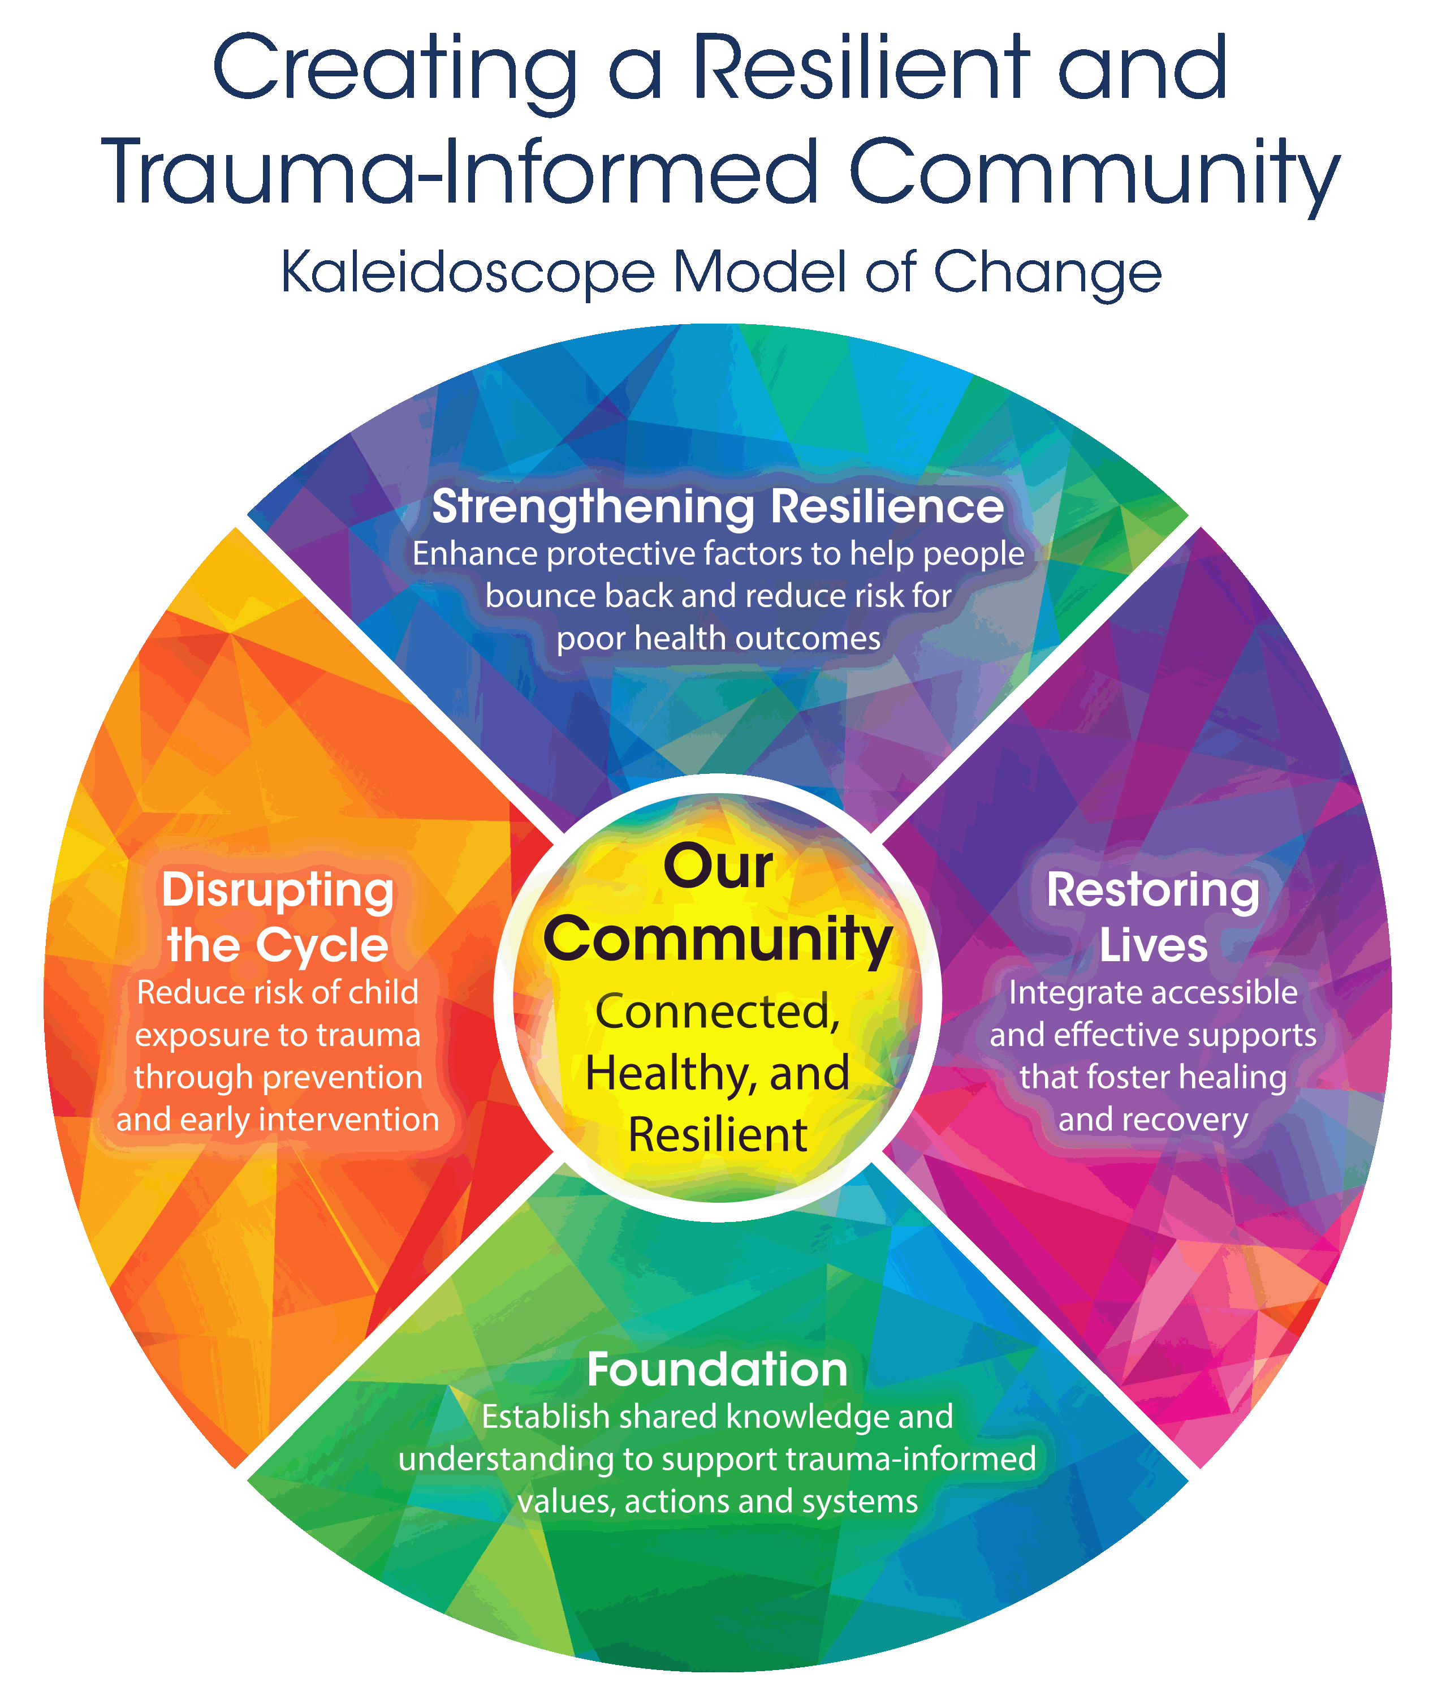

More information about the Resilient and Trauma-Informed Community initiative can be found at:
www.resilientcommunitieswi.com

Questions, comments and/or to learn more about [Organization name]’s partnership in the Resilient and Trauma-Informed Community initiative, please email:
[list contact info for primary organization contact(s)]

