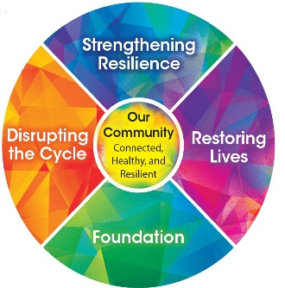
Creating your own Menti check-in tool

Step 1: Go to https://www.mentimeter.com/signup. and sign-up for your free account using your Facebook profile, Google account or an email address.

Step 2: Once you have created your account, you can create a new presentation (blue button on the top left of the dashboard).
Once you start a new presentation you can decide from a variety of question types.
Feelings Option:
If you would like to use the spider web format that we have used in our RTIC meet-ups the question type is called “Scales”.
The question is: How are you feeling?
The responses are called “Statements” for this question type are listed in this order:
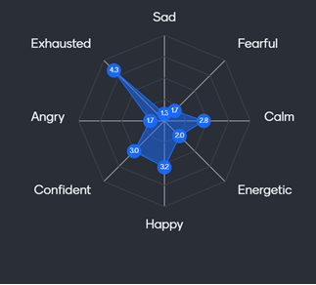
Happy
Calm
Confident
Exhausted
Sad
Frustrated/Angry
Anxious/Fearful
Energetic
The Result Layout is: Spider Chart
The Dimensions (default)
Strongly disagree 1
Strongly agree 5

Another display option that you may want to use for displaying your result is the “Sliders”. The sliders provide the averages in a stacked format that may be easier to interpret. The responses (statements) for this format are the same but we suggest the following order:
Energetic
Calm
Confident
Happy
Sad
Anxious/Fearful
Frustrated or Angry
Exhausted

Behaviors Option:
The Behaviors Option asks about areas of our life that are important to our overall health and mental health.
The question is: How would you rate the following areas of your health?
The responses are called “Statements” for this question type are listed in this order:
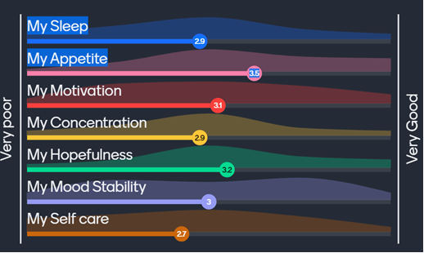
My Sleep
My Appetite
My Motivation
My Concentration
My Hopefulness
My Mood Stability
My Self Care
The Result Layout is: Sliders
The Dimensions (default)
Very Poor 1
Very Good 5

Step 3: The Menti Code that you will give your participants is generated automatically when you finish your slide and press the Present button on the top right.
To use your new Menti check-in tool, you will log in to your mentimeter account, open your presentation and ask your participants to go to Menti.com. Have your participants use the code at the top of the slide. Your Mentimeter will save your poll and the results. Please note that Menti codes do expire if they are not used. If you go back to a previously used slide and there is no menti code at the top of the slide your code has expired! Simply re-create your slide to get a new code.

