RTIC Foundation Training
Facilitator Guide for Organizations
May 2023

The Foundation Training creates common language and understanding of Adverse Childhood Experiences (ACEs), trauma-informed care, resilience, and building empathy skills, both professionally and personally.

Facilitator Training. Facilitator training is available at the end of every scheduled Foundation training. Check the schedule on the RTIC website: www.resilientcommunitieswi.com. Or contact Catherine Kolkmeier at ckolkmeier@uwlax.edu or 608-785-5151 for a walkthrough.

Accessing the Film. The training is built around the documentary Resilience: The Biology of Stress and the Science of Hope. Inquire with the RTIC Support Team to borrow a copy of the DVD. UWL and Viterbo faculty/staff can access digital copies through their campus libraries. Individuals can also rent ($2-3) or purchase ($8) the film in streaming format through Apple TV, Vudu, Google Play Movies, and YouTube.
- TIP: Note that there are several Bonus Content videos on the DVD that may be of use to your team.
- Also check out these resources from the Resilience film website: https://kpjrfilms.co/resilience/resources/

Materials: All materials are on the RTIC website: https://www.resilientcommunitieswi.com/facilitator-guide.html
- PowerPoint file: “Foundation Slide Deck for Organizations”
  - Slide notes include bulleted talking points AND full script. Download and modify for your need.
  - TIP: There are several optional or facilitator-only slides that are “hidden” and will not display unless you unhide them. Right-click on the slide thumbnail (left side of screen) and choose “Hide Slide” to toggle between hiding and unhiding slides.
- Script (for printing)
- Handouts:
  - “RTIC Overview” – introduces the Resilient and Trauma-Informed Community (RTIC) effort
  - PACE’s Handout – describes the 3 realms of ACEs
Presenting. This training can be offered in-person or online.
- Screen Sharing. If you are using Zoom or other online platform, you will not be able to stream the film by sharing your screen. If you do not have a physical DVD, we recommend you ask your participants to watch the film ahead of the training on their own devices.
  - TIP: When presenting the DVD using Zoom, when choosing “Share Screen,” check the boxes marked “Share sound” and “Optimize for video clip” in the lower-left corner of the “Share” screen (see screenshot below):
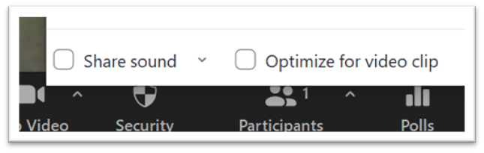
- YouTube videos. There are two videos embedded in the slides.
  - TIP: Queue these up in a browser before you begin by “Ctrl-click”ing each slide. Allow any ads to play and then pause at the beginning until ready to play.
Direct Links:
  - Cleveland Clinic Empathy video: https://www.youtube.com/watch?v=cDDWvj_q-o8
  - Brene Brown Empathy vs. Sympathy video: https://www.youtube.com/watch?v=1Evwgu369Jw
- Handouts. There are two optional handouts, listed above. The slides notes tell you when to hand out each one.
  - TIP: If presenting online, open the handouts folder before you begin so you can easily drag or upload the documents into the chat at the appropriate time.
- Group discussions/Table talks. There are several group discussions in the presentation. A Table Talk Guide is available in the folder for in-person groups. For large groups, we recommend breaking into smaller groups, either at in-person tables, or in online breakout rooms. The chat function can also be used when presenting online.
- Improvising. Feel free to modify the contents of the presentation to fit your organization. Add your logo or other artwork. Provide personal anecdotes that relate to the content. This helps connect with the content.
- Attending a training. We recommend you attend a training before you present, even if you’ve seen the training before. As a potential facilitator, you’ll see it differently and get ideas. Each Foundation training ends with a train-the-trainer segment that will walk through this facilitator guide and answer your questions. Or contact Catherine Kolkmeier at ckolkmeier@uwlax.edu or 608-785-5151 for a walkthrough.

