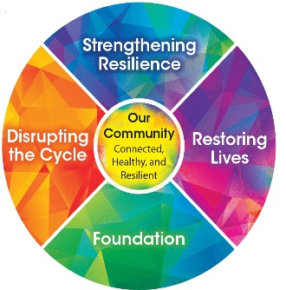
Creating your own Menti self-care check-in tool
Step 1: Go to https://www.mentimeter.com/signup. and sign-up for your free account using your Facebook profile, Google account or an email address.
Step 2: Once you have created your account, you can create a new presentation (blue button on the top left of the dashboard).
Once you start a new presentation you can decide from a variety of question types.
The updated RTIC Check-in question asks about areas of our life that are important to our overall health and mental health.
The question is: How would you rate the following areas of your health?
The responses are called “Statements” for this question type are listed in this order:
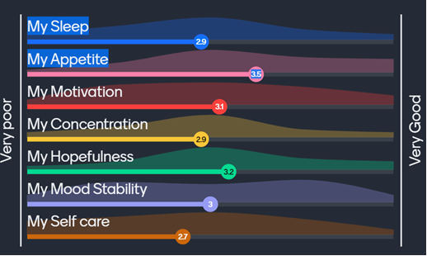
My Sleep
My Appetite
My Motivation
My Concentration
My Hopefulness
My Mood Stability
My Self Care
The Result Layout is: Sliders
The Dimensions (default)
Very Poor 1
Very Good 5

Step 3: The Menti Code that you will give your participants is generated automatically when you finish your slide and press the Present button on the top right.
To use your new Menti check-in tool, you will log in to your mentimeter account, open your presentation and ask your participants to go to Menti.com. Have your participants use the code at the top of the slide. Your Mentimeter will save your poll and the results. Please note that Menti codes do expire if they are not used. If you go back to a previously used slide and there is no menti code at the top of the slide your code has expired! Simply re-create your slide to get a new code.

Here is an explanation for each of the response categories:
Sleep: How would you describe your sleep? Have you being sleeping well or are you having difficulty falling asleep, staying asleep, sleeping too much, or having nightmares?
Appetite: How has your appetite been? Have you had changes in your appetite? This could be overeating or undereating.
Motivation: Have you been motivated this week?
Concentration: Have you been able to concentrate on what you need to get done?
Hopefulness: How is your sense of hopefulness this week?
Mood Stability: How has your mood been? Do you have many sudden mood changes?
Self Care: Have you been caring for yourself? Doing this specifically for your own self-care?

